Media and Information Literacy

Interviewee #1

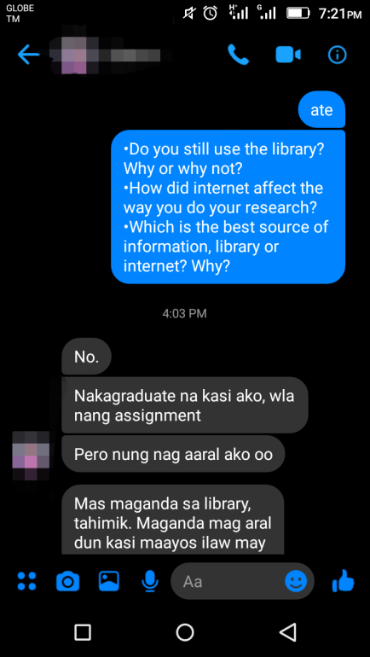 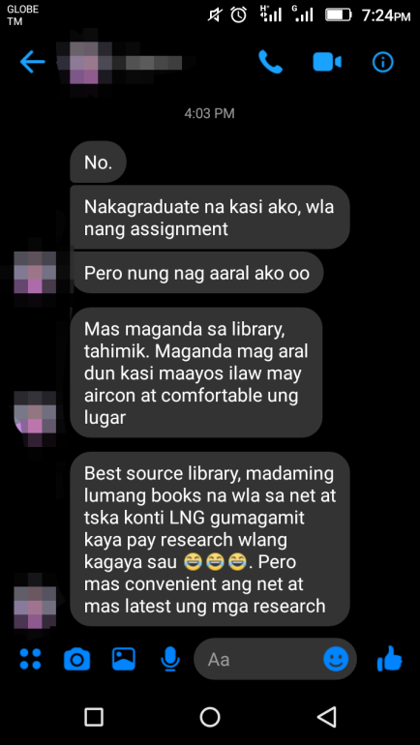

Interviewee #2

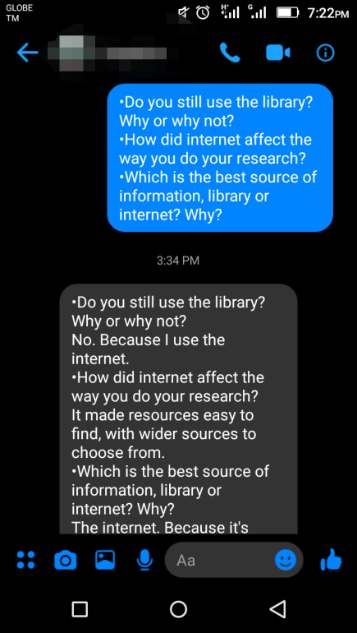 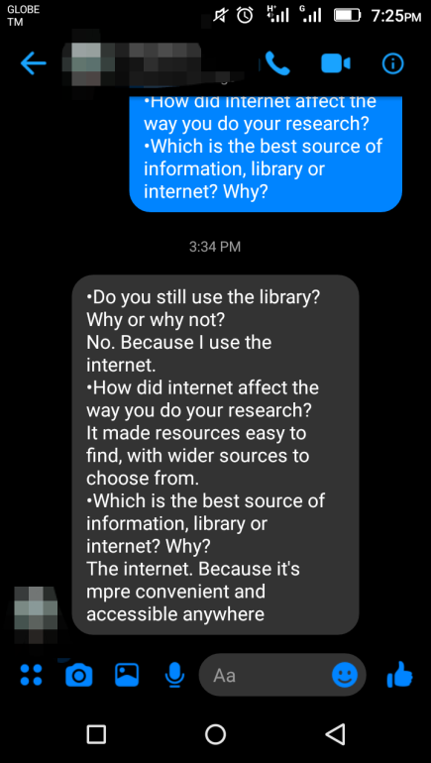

Interviewee #3

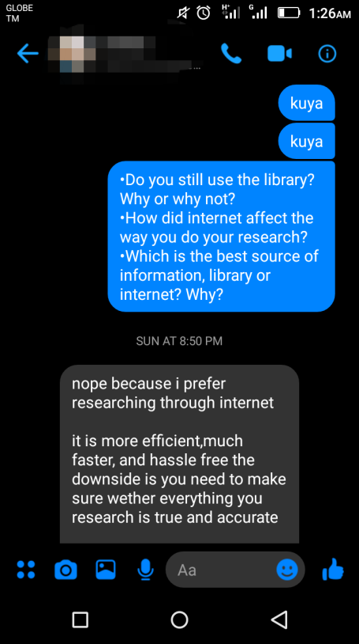 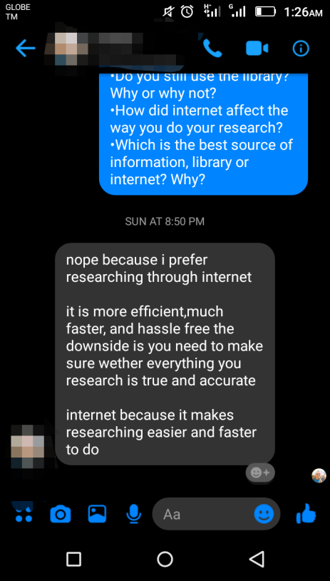

Submitted by: Adolf Jonnel F. Villaverde

11 – St. John Paul II

Submitted to: Mrs.Myla Logatoc